**23-Sep-2024**

**Internship Day - 46 Report:**

**LAB 9: WIRELESS NETWORK USING BASIC ROUTING**

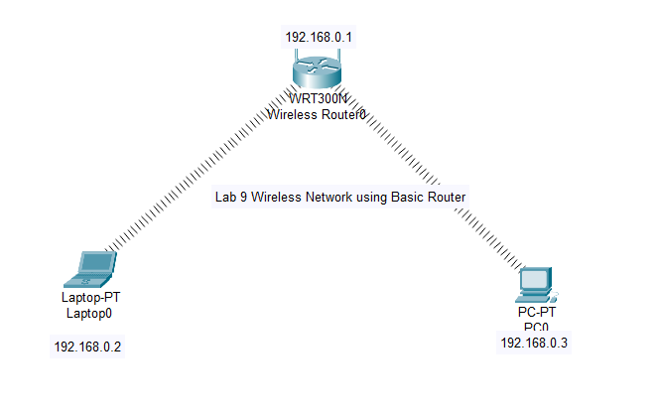

To configure a wireless network using a basic router, as shown in the diagram, follow these step-by-step instructions:

**Components in the Diagram:**

* Wireless Router (WRT300N): IP address 192.168.0.1
* Laptop-PT: IP address 192.168.0.2
* PC-PT: IP address 192.168.0.3

**Configuration Steps:**

**Step 1: Configure the Wireless Router (WRT300N)**

1. **Access the Router Configuration:**

* Connect to the router by entering its default IP address (`192.168.0.1`) in a web browser from either the laptop or the PC.
* Log in using the default credentials (usually `admin/admin` for most routers, orrefer to the router’s manual).

**2. Set the Wireless Network:**

* Navigate to the Wireless Settings or Wireless Setup section.
* Enable wireless networking and set:
* SSID (Network Name): Choose a name, e.g., Lab9_Wireless
* Channel: Set to `Auto` or a specific channel to avoid interference.
* Mode: Choose mixed mode if you have different types of devices.
* Security: Enable WPA2-PSK encryption for better security.
* Set a Wi-Fi password for the wireless network.

**3. Set the Router’s LAN Settings:**

* Go to LAN Settings.
* Ensure the router’s IP address is 192.168.0.1.
* Subnet Mask should be 255.255.255.0.
* Enable DHCP Server (if needed) and set the IP address range (e.g., `192.168.0.2 192.168.0.50`).

**4. Save and Reboot:**

* Apply the changes and reboot the router if necessary.

**Step 2: Configure the Laptop (Laptop-PT)**

**1. Connect to the Wireless Network:**

* On the laptop, open the wireless network settings.
* Scan for available networks and select `Lab9_Wireless` (the SSID you set on the router).
* Enter the password you configured earlier.

**2. Set the IP Address:**

* In the Network and Sharing Centre, go to Change adapter settings.
* Right-click on the wireless adapter and go to Properties.
* Select Internet Protocol Version 4 (TCP/IPv4) and click on Properties.
* Set a Static IP address:

IP: 192.168.0.2

Subnet Mask: 255.255.255.0`

Default Gateway: 192.168.0.1 (the router's IP address)

Set the DNS server as the same as the router's IP (`192.168.0.1`) or any external DNS server (e.g., `8.8.8.8` for Google DNS).

**3. Test the Connection:**

* Open the Command Prompt and type `ping 192.168.0.1` to test connectivity to the router.
* You should receive replies, indicating a successful connection.

**Step 3: Configure the PC (PC-PT)**

**1. Set the IP Address:**

* + Go to the Network and Sharing Centre, open Change adapter settings, and right-click on the Ethernet adapter.
  + Set the Static IP address for the PC:

IP: 192.168.0.3

Subnet Mask: 255.255.255.0

Default Gateway: 192.168.0.1 (the router's IP)

DNS Server: 192.168.0.1 or 8.8.8.8.

**2. Test the Connection:**

* Open the Command Prompt on the PC and type `ping 192.168.0.1` to check the connection to the router.

**Step 4: Test the Network**

**1. Test Communication Between Devices:**

* + From the laptop, open Command Prompt and type `ping 192.168.0.3` to check if the laptop can reach the PC.
  + From the PC, type `ping 192.168.0.2` to check if the PC can reach the laptop.
  + Both devices should be able to communicate with each other via the wireless router.

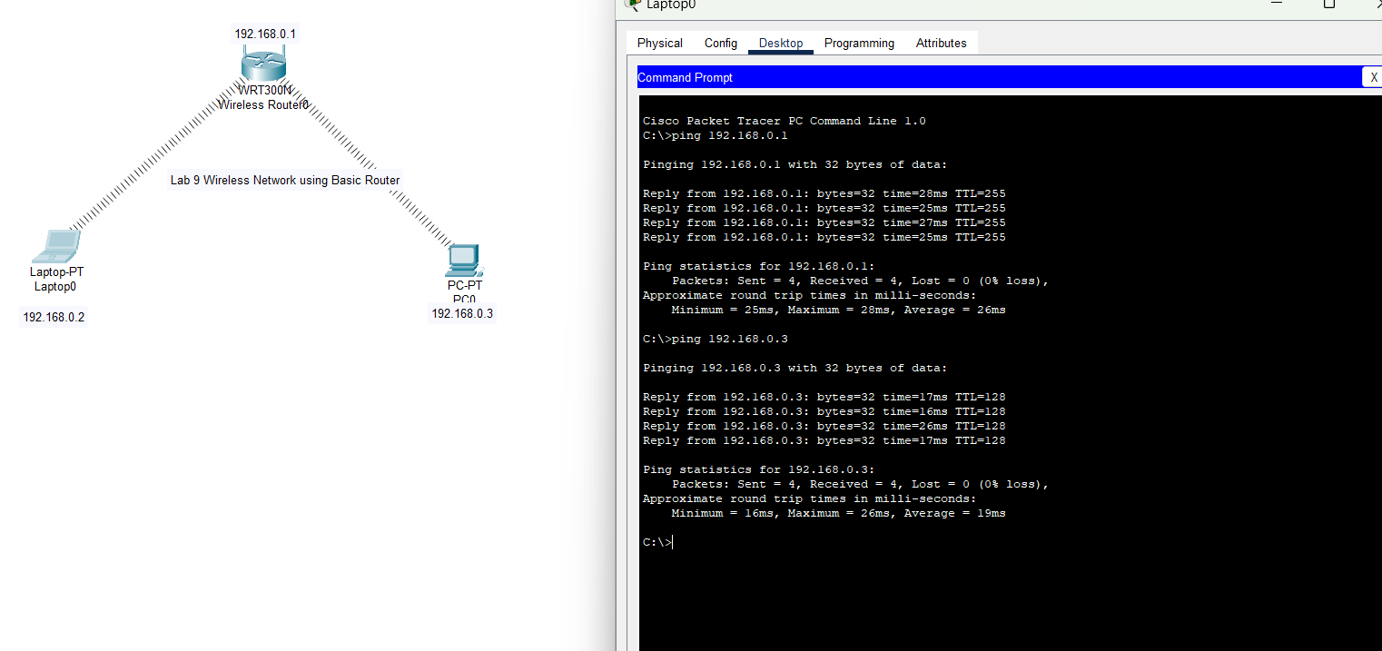

**24-Sep-2024**

**Internship Day - 47 Report:**

**LAB 10: ACCESS POINT & PRINTER CONNECT WITH NETWORK**

**Components in the Diagram:**

* **Router (2811)**:

Interfaces:

Fa0/0: 192.168.1.1

Fa0/1: 192.168.2.1

* **Switch (2960-24TT)**:

Connected to Router (Fa0/0) and Access Point (Fa0/2).

* **Access Point (AP)**: Connected to the switch.
* **Laptop-PT (Laptop0)**: 192.168.1.3
* **Laptop-PT (Laptop1)**: 192.168.1.4
* **Printer-PT**: 192.168.1.5
* **Second Switch**: Connected to the second subnet 192.168.2.0
* **Laptop-PT (Laptop2)**: 192.168.2.2

**Configuration Steps:**

**Step 1: Configure the Router (2811)**

1. **Access the Router:**Connect a console cable to the router and access it through a terminal emulator (e.g., PuTTY, Tera Term).
2. **Configure the Router Interfaces:**

* **Enter global configuration mode:**
* Router> enable
* Router# configure terminal
* **Fa0/0 (192.168.1.1):**
* Router(config)# interface Fa0/0
* Router(config-if)# ip address 192.168.1.1 255.255.255.0
* Router(config-if)# no shutdown
* **Fa0/1 (192.168.2.1):**
* Router(config)# interface Fa0/1
* Router(config-if)# ip address 192.168.2.1 255.255.255.0
* Router(config-if)# no shutdown
* **Save the configuration:**
* Router(config)# end
* Router# write memory

**Step 2: Configure the Access Point (Access Point-PT)**

1. **Access the Access Point Configuration:**

Connect to the Access Point through a web browser or console if available.

1. **Set Wireless Network Settings:**

Go to the **Wireless Settings** or **Wireless Setup** section.

Set the following:

**SSID**: Choose a name like Lab10_Wireless

**Channel**: Set to Auto or a specific channel to avoid interference.

**Security Mode**: Set **WPA2-PSK** for security and provide a password.

1. **Configure the Access Point's IP:**

Navigate to **LAN Settings**.

Assign a **Static IP** in the range of 192.168.1.x, e.g., 192.168.1. x

**Subnet Mask**: 255.255.255.0

**Gateway**: 192.168.1.1 (the router's IP)

1. **Save and Reboot the Access Point**.

**Step 3: Configure the Laptops (Laptop-PT0 and Laptop-PT1)**

1. **Laptop-PT0 (192.168.1.3)**:

Go to the **Network and Sharing Center**.

Choose the **Wireless network** and connect to Lab10_Wireless.

Set a **Static IP address**:

**IP Address**: 192.168.1.3

**Subnet Mask**: 255.255.255.0

**Default Gateway**: 192.168.1.1

**DNS**: 192.168.1.1 or a public DNS like 8.8.8.8.

1. **Laptop-PT1 (192.168.1.4)**:

Repeat the same steps as Laptop-PT0 but set the IP address as 192.168.1.4.

**Step 4: Configure the Printer (Printer-PT)**

1. **Assign IP Address to Printer:**

Access the printer configuration through its web interface or physical interface.

Set the **IP Address** as 192.168.1.5, Subnet Mask 255.255.255.0, and Default Gateway as 192.168.1.1.

Save the settings and restart the printer.

**Step 5: Configure the Second Switch and Laptop on the 192.168.2.0 Network**

1. **Configure Switch1:**

Connect a laptop via console and access the CLI.

The switch operates in Layer 2, so no IP address is required on ports.

1. **Laptop-PT2 (192.168.2.2):**

Set a static IP on the laptop:

**IP Address**: 192.168.2.2

**Subnet Mask**: 255.255.255.0

**Default Gateway**: 192.168.2.1 (the router's Fa0/1 interface).

Test the network connection by pinging the router and other devices.

**Step 6: Test the Network Connectivity**

1. **Test Wireless Laptops:**

From **Laptop-PT0** and **Laptop-PT1**, open the command prompt and ping 192.168.1.1 (the router).

Ping the printer at 192.168.1.5.

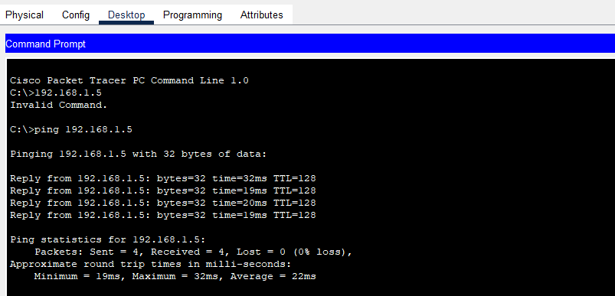

**25-Sep-2024**

**Internship Day - 48 Report:**

Physically Perform in Lab.

**26-Sep-2024**

**Internship Day - 49 Report:**

**LAB 11: SIMPLE MAIL TRANSFER PROTOCOL**

**Components in the Diagram:**

* **Routers (2811)**: Routers interconnecting three different networks:

**Network 1 (Left)**: 192.168.1.0/24

**Network 2 (Center)**: 192.168.2.0/24

**Network 3 (Right)**: 192.168.3.0/24

* **Switches (2960)**: Two switches connecting laptops and the email server to routers.
* **Email Server (SMTP)**: 192.168.2.2 configured to provide SMTP services.
* **Laptops**: Laptops connected to their respective networks:

**Pankaj Laptop**: 192.168.1.x

**Ram Laptop**: 192.168.1.x

**Sham Laptop**: 192.168.3.x

**Rohan Laptop**: 192.168.3.x

**Configuration Steps:**

**Step 1: Configure Router 1 (Left Router)**

1. **Access Router1** using the console or terminal.
2. **Configure Interfaces**:

**Fa0/0 (192.168.1.1)**:

Router1> enable

Router1# configure terminal

Router1(config)# interface Fa0/0

Router1(config-if)# ip address 192.168.1.1 255.255.255.0

Router1(config-if)# no shutdown

**Fa0/1 (10.0.0.1)** for interconnection to Router2:

Router1(config)# interface Fa0/1

Router1(config-if)# ip address 10.0.0.1 255.255.255.0

Router1(config-if)# no shutdown

1. **Enable Routing** between interfaces:

Router1(config)# ip routing

1. **Set up Static Routes** for other networks:

Router1(config)# ip route 192.168.2.0 255.255.255.0 10.0.0.2

Router1(config)# ip route 192.168.3.0 255.255.255.0 10.0.0.2

1. **Save Configuration**:

Router1(config)# end

Router1# write memory

**Step 2: Configure Router 2 (Central Router)**

1. **Access Router2** via console.
2. **Configure Interfaces**:

**Fa1/0 (10.0.0.2)** (Link to Router1):

Router2> enable

Router2# configure terminal

Router2(config)# interface Fa1/0

Router2(config-if)# ip address 10.0.0.2 255.255.255.0

Router2(config-if)# no shutdown

**Fa0/1 (192.168.2.1)** (Local network):

Router2(config)# interface Fa0/1

Router2(config-if)# ip address 192.168.2.1 255.255.255.0

Router2(config-if)# no shutdown

1. **Set up Static Routes**:

Route to **192.168.1.0/24** via 10.0.0.1 (Router1):

Router2(config)# ip route 192.168.1.0 255.255.255.0 10.0.0.1

Route to **192.168.3.0/24** via 40.0.0.1 (Router3):

Router2(config)# ip route 192.168.3.0 255.255.255.0 40.0.0.1

1. **Save Configuration**:

Router2(config)# end

Router2# write memory

**Step 3: Configure Router 3 (Right Router)**

1. **Access Router3** through the console.
2. **Configure Interfaces**:

Router3> enable

Router3# configure terminal

Router3(config)# interface Fa0/0

Router3(config-if)# ip address 192.168.3.1 255.255.255.0

Router3(config-if)# no shutdown

**Fa0/1 (40.0.0.2)** for interconnection to Router2:

Router3(config)# interface Fa0/1

Router3(config-if)# ip address 40.0.0.2 255.255.255.0

Router3(config-if)# no shutdown

1. **Enable Routing** between interfaces:

Router3(config)# ip routing

1. **Set up Static Routes**:

Route to **192.168.1.0/24** via 40.0.0.1 (Router2):

Router3(config)# ip route 192.168.1.0 255.255.255.0 40.0.0.1

Route to **192.168.2.0/24** via 40.0.0.1 (Router2):

Router3(config)# ip route 192.168.2.0 255.255.255.0 40.0.0.1

1. **Save Configuration**:

Router3(config)# end

Router3# write memory

**Step 4: Configure the SMTP Server**

1. **Access the Email Server** (192.168.2.2) through the console or terminal.
2. **Configure the SMTP Server Settings**:

* Go to **Services** > **Email**.
* **SMTP**: Enable the SMTP service.

Set up the following:

**Domain Name**: example.com

**Server Name**: mail.example.com

Add user accounts for each laptop:

**Pankaj**: pankaj@example.com

**Ram**: ram@example.com

**Sham**: sham@example.com

**Rohan**: [rohan@example.com](mailto:rohan@example.com)

**Step 5: Configure the Laptops for Email**

1. **Access Each Laptop** (Pankaj, Ram, Sham, Rohan) and configure email clients:

Open the **Email** application.

Set up the following details:

* **Incoming Mail Server**: mail.example.com
* **SMTP Server**: 192.168.2.2
* **Email Address**: Use respective accounts:

**Pankaj**: pankaj@example.com

**Ram**: ram@example.com

**Sham**: sham@example.com

**Rohan**: rohan@example.com

**Password**: Set the respective password for each user.

1. **Send Test Emails**:

* From Pankaj's laptop, send an email to **Ram** at [ram@example.com](mailto:ram@example.com).
* From Sham's laptop, send an email to **Rohan** at rohan@example.com.

**Step 6: Verify SMTP Communication**

* Use **Packet Tracer's simulation mode** to verify that the SMTP packets are transmitted between the email server and the laptops across the different networks. The routers should correctly route the packets based on the static routes configured.

**27-Sep-2024**

**Internship Day - 50 Report:**

Physically Perform in Lab.